Software and Hardware Requirements
Software Required
https://in.mathworks.com/downloads/
    - MATLAB
    - Simulink
    - Motor Control Blockset
    - Control System Toolbox
    - Matlab Coder
    - Simulink Coder
    - Embedded Coder
    - Simulink Control Design
Hardware Required
- MCLV-2 development board configured with ‘EXTERNAL’ op-amp matrix board
https://www.microchipdirect.com/product/DM330021-2
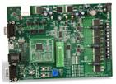

- ATSAME70 Motor Control Plug in Module
https://www.microchipdirect.com/product/MA320203
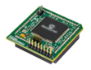
- 24V 3-Phase Permanent Magnet Synchronous Motor with Encoder
https://www.microchipdirect.com/product/AC300022
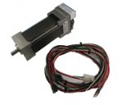
- MPLAB ICD 4 In-Circuit Debugger / PICkit 4 In-Circuit Debugger
https://www.microchipdirect.com/product/DV164045
https://www.microchipdirect.com/dev-tools/PG164140?allDevTools=true

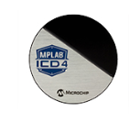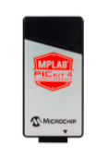

- 24V power supply
https://www.microchipdirect.com/product/AC002013
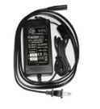
- Debugger Adapter board for MPLAB ICD4
https://www.microchipdirect.com/product/AC102015
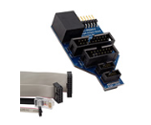
- FTDI cable / FT232RL FTDI USB to UART
https://ftdichip.com/product-category/products/cables/
FTDI cable supporting 12MBaud is the best
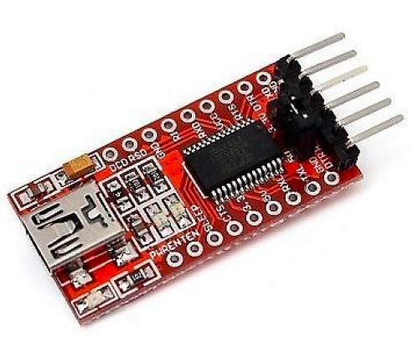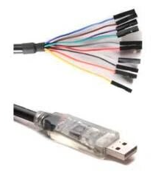

- Motor phase connections and encoder connections to MCLV2 should be as shown in the figure below. Connect White, Black, Red coloured wires (phase connections) coming from P1 header of motor to M1, M2, M3 respectively of J7 header on MCLV2. Similarly, connect Red, Black, White, Blue coloured wires coming from P3 header of motor to +5V, GND, HA, HB respectively of J7 header on MCLV2.
